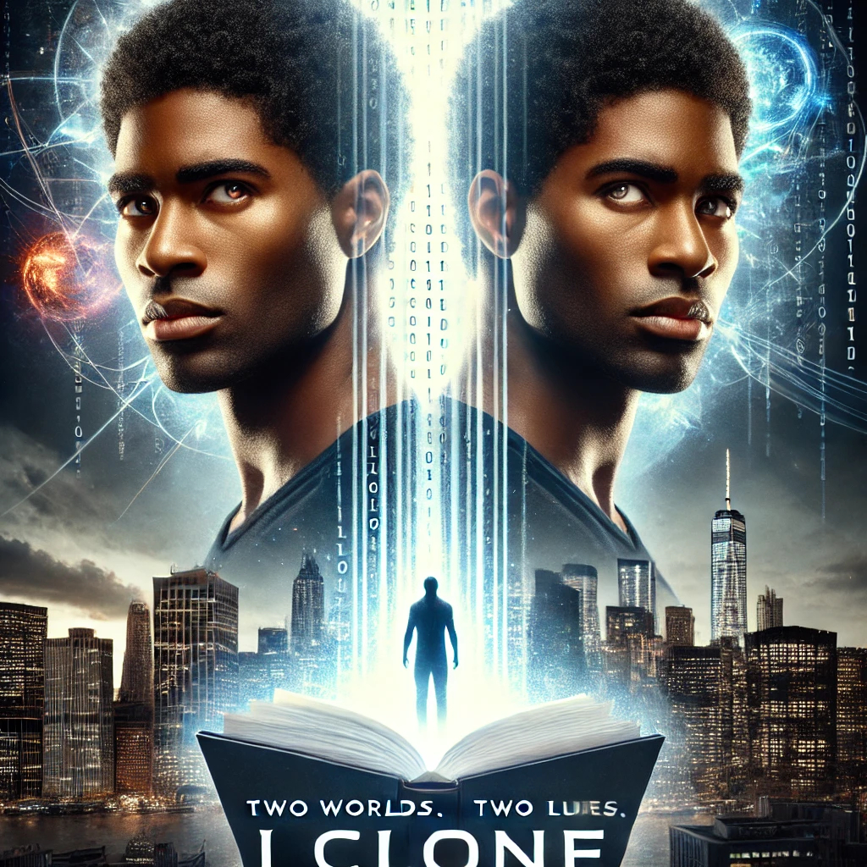

I CLONE
Darrell Pender
Barrow Publications
2004 All Rights Reserved

Table of Contents
Any Other Day 5
Character Profile 14
Raymond Wake 15
Tom Woken 16
Shawn Williams 17
Richard Johnson 18
Raymond Johnson 19

Any Other Day
My day begins just like any other. I wake up early in my small Brooklyn apartment, shower, shave, and get ready for work at Chase Bank. I make breakfast, grab my bag, and head out the door for my daily commute. It's the same routine I follow every weekday, the daily grind.
I head to work, unable to shake the feeling that something's wrong. I can't quite figure out what it is, but there's a persistent nagging in my mind. Still, I try to push it aside and go on with my day. After all, it's another day of dealing with spreadsheets and endless emails.
I had no idea this day would be anything but ordinary, but it ended up changing my life forever.
I went through my day, but I couldn't shake the feeling that something was wrong. It felt like I was being watched with every move I made. I tried to dismiss it, telling myself it was just my imagination playing tricks.
I arrived, sat at my desk for breakfast, and checked my emails. The office had a strange, almost eerie feeling. It was as if time had stopped, and everything around me was changing. I looked around, trying to see if my friend Shawn had arrived, but he was nowhere to be seen.
Sitting there, I couldn't help but feel like I was in some kind of time warp. The people around me felt distant and different, and time seemed to crawl. I tried to shake the feeling and focus on my work, but it was no use. The sense of being watched only intensified.
After about an hour, I took a break and headed to the cafeteria for a coffee and a cinnamon swirl. While waiting in line, I tried to calm myself by telling myself I was just paranoid. When I reached the cashier, Sara greeted me with a smile, but I could tell she was a little surprised to see me. 'Back already?' she asked. 'I just came down on my break,' I replied. 'You must be getting old,' she joked, 'your memory's already gone.' I laughed nervously, paid for my food, and returned to my desk.
I settled back into my work when the phone rang. 'Good morning, finance; Raymond speaking,' I answered. It was my supervisor, Tom Woken. 'Raymond, regarding your presentation.' My heart sank as I realized I had forgotten entirely the fiscal presentation due that day.
I stared at the screen, trying to figure out what was happening. Was someone pranking me? Did I accidentally send it to Tom without realizing? I couldn't remember doing that.
I reviewed the presentation and noticed something odd. The formatting and wording were different from what I usually use. It was as if someone else had finished it for me.
I tried to shake off the unease and focus on my work, but the more I thought about it, the more my paranoia came back. Was someone watching me? Did they have access to my computer? Was someone trying to sabotage me or set me up?
I took a break and went to the break room to clear my head. That's when I saw Richard, the security guard, watching me from the corner of his eye. I tried to ignore it, but the feeling of being watched grew stronger.
I confronted Richard and asked if there was a problem. He looked surprised and denied watching me, claiming he was keeping an eye on things. But I wasn't convinced.
The day went on, and my paranoia only grew stronger. The feeling of being watched never left me. I couldn't shake the sense that something was wrong, that I wasn't alone. I started to wonder if I was losing my mind.
I kept experiencing strange things all day. People kept saying I had already done things I didn't remember. It all felt way too surreal. I couldn't help but wonder if I had somehow entered the Twilight Zone and if Rod Sterling would show up any second to start his famous narration. As I imagined different scenarios, I thought it would make for an exciting episode.
Finally, lunchtime arrived. I grabbed my jacket, hoping for a peaceful break and an explanation of what was happening to me. How did I finish a presentation I hadn't even started? Did I work on it last night and forget about it? Tom could be demanding and often transferred his stress onto his employees. I tried to consider all possibilities, but couldn't find a logical explanation. I pushed it to the back of my mind, attributing it to stress.
After finishing my lunch break, I headed back to the office building. As I approached the entrance, I pulled out my ID card to swipe at the security desk. However, to my surprise, the card didn’t work. I tried several times, but it still wouldn't grant me access. I decided to go to the security office to find out what was wrong.
When I arrived, I saw Richard, the security officer. "Hey Richard, how are you today?" I greeted him. "I'm fine, Mr. 'P,' what can I do for you?" he replied. "I am having trouble with my ID card," I explained. Richard took my card and said, "Hmmm, let me see your card. I will run it through the computer to verify your card is active." I handed over my ID card, hoping it was a minor issue.
"This is strange," exclaimed Richard, chuckling. "What is it?" I asked, confused. Trying to compose himself, Richard replied, "Well, according to our records, you don't work here." My jaw dropped in disbelief. "What? I have worked here for ten years, and you have known me for at least the last five years,” I said, increasingly frustrated.
Richard finally composed himself and said, "I know, Mr. 'P,' please calm down. You must go to employment relations to get this straightened out before I can issue a new ID card." I sighed in resignation as Richard handed me a temporary building pass. "Thanks, Richard," I said, heading out of the security office and toward employment relations.
I was feeling frustrated and confused about how someone could have messed up my employment record. So, I reluctantly went to the personnel department. When I entered the employment office, I saw it was full of job applicants, some filling out applications while others were typing on their keyboards, testing their skills.
One of the office workers looked at me as I approached the counter. I spoke up, "Excuse me, I work here." It was as if she should have recognized me, but instead, she asked, "Oh, how can I help you?"
I just came from the security office," I explained. "The system said that I don't work here. I have worked here for ten years in finance for Tom Woken. I am here to get this straightened out so I can be issued a new ID.
"What is your name, sir?" Angela asked as I noticed her ID. "My name is Raymond Johnson," I replied.
Angela turned to her computer and started typing. After a moment, she looked at me and said, "Your name does not show up, Mr. Johnson."
I was annoyed by her response and snapped back, "Duh! I know that’s why I am here. Somehow, I’ve been deleted, or whatever happened to my profile."
Angela got up from her computer and said, "Have a seat, Mr. Wake. First, I need to find your employment application. Then, we can input your data into the computer. Oh, when did you start here?"
I started here in May of 1989," I replied.
I sat for nearly twenty minutes while Angela searched for my employment application. Finally, she came out of the back room and motioned for me to come to her desk. "I'm sorry, Mr. Johnson, but we have no file for you," she said. My face flushed as the blood rushed to it. "What do you mean you have no record of me?" I nearly shouted. "Call extension 2856. It's Tom Woken's line; he can verify all the information."
Angela dialed the phone and muttered a few words before finally hanging up. Walking over to the counter, I asked what Tom had said. She replied, "Mr. Woken has no record or recollection of ever having an employee by your name."
I hurried out of the personnel office, anger and confusion still rushing through me. My mind was flooded with questions and disbelief. How could Tom deny my existence after I worked for him for the past ten years? I knew I had to see him face-to-face to get some answers. As I stepped into the elevator and pressed the button for the 17th floor, I couldn't shake the feeling that I had entered some alternate reality.
The elevator doors opened on the 17th floor, and I felt disoriented by the unfamiliar faces around me. The colleagues I had worked with for a decade were nowhere to be seen, and I couldn't help but wonder if the entire floor had been moved overnight. Despite my confusion, I pressed on, determined to find Tom and figure out what was going on.
Walking down the hallway toward Tom's office, I couldn't shake the feeling that something was wrong. When I reached his workspace, I was greeted by a completely different man than the one I had known for the past ten years. I stammered and faltered as I tried to explain my situation, my mind racing with the thought that a doppelganger might have replaced Tom.
"Excuse me," I managed to stammer, "but do you know what happened to Tom Woken? I've worked with him for ten years and need to speak with him urgently." The man looked at me quizzically before responding, "I am Tom Woken. Can I help you?" I felt as if the ground had dropped from beneath me, my head swimming with disbelief. "No, no," I finally managed to gasp, "the Tom Woken I know is an elderly man with white hair and thick glasses."
I staggered back, feeling faint and overwhelmed, and couldn't help but wonder what kind of strange and sinister plot had unfolded around me. Had I wandered into a parallel universe or been the victim of some elaborate hoax? I knew I had to get to the bottom of this, no matter what it took.

There is no one matching that description in this department. Is it finance you need?" the man said, pulling me back to reality. I quietly replied, "Yes," and left the office feeling worse than ever. I started looking for Shawn, my best friend. He would know what was going on; this had to be some cruel joke someone was playing on me.
I frantically searched the entire 17th floor with no sign of Shawn or anyone I knew. I was about to give up when I saw someone I recognized, Linda, a colleague I had worked with for years. She was walking toward me, but I could see she was looking right through me as she got closer. She didn't seem to recognize me at all.
I called her, but she kept walking as if I wasn't there. It was as if I had become invisible to everyone I knew. Panic took over as I realized I was alone in this strange, unfamiliar place. What was happening to me?
I am starting to believe I’ve entered some alternate universe where I don't work for CHASE Banking. Despite my confusion, I knew I had to talk to Richard in security. He confirmed that I’ve worked here for the past 10 years. In a daze, I staggered into the elevator, my focus on seeing Richard. The slow hum of the elevator signaled to my brain as I leaned against the wall. I didn't realize I had reached the lobby until someone said, "Sir, this is the first floor," as they entered the elevator.
Once again, I headed to the security office to speak with Richard. Richard, something is wrong. As Richard turned to face me, he looked at me as if he didn’t know me. "How may I help you, Sir?" he replied. Richard, it's me, Mr. "P." Stop playing games now; enough is enough, I replied in a panic.
I'm sorry, sir, but you have mistaken me for someone else. Richard, this isn't funny anymore, I shouted. As you told me, I went to Personnel and Finance; no one has a record of me working here. The entire 17th floor has relocated to God knows where.
What's going on? Richard replied again, "I'm sorry, but you have me confused with someone else. I have not seen you before now. But, sir, if you continue to become abusive, I will have to ask you to leave."
Okay, OK, Richard, I give up. What's the game, and who put you up to this? Are these ten years of torture CHASE has subjected its employees to? Richard holds out his hand. "Can I see your ID?" You took my ID this afternoon when I came back from lunch because it wasn't working.
Richard's expression changed from confusion to concern as he looked at the ID card. "Sir, this ID card doesn't belong to you," he said slowly. "It belongs to Michael Peters, who used to work here but left the company six years ago."
My heart sank as Richard's words sank in my mind. Could I have been living a lie all these years? How did this happen? I asked Richard if there was any way to verify my employment, but he said it would be impossible without proper ID. I left the security office feeling lost and confused.
I stepped out of the building and noticed everything around me looked different, as if I was seeing it for the first time. The streets seemed unfamiliar, and the people passing by were strangers. I sat on a nearby bench, trying to understand what was happening to me.
Then, I noticed a newspaper lying on the bench beside me. I picked it up and read the date: March 19, 2023. That was impossible; I last remembered going to bed on March 18, 2021. It felt like two years of my life had been erased.
Feeling disoriented and alone, I didn't know what to do next. Was I losing my mind, or was this some elaborate prank? I went to the hospital to see if a doctor could help me understand what was happening. But as I approached the entrance, I realized I didn't know my name. It was as if I had been erased from the world.
I needed to find answers and understand what was going on. Maybe there was some mix-up or mistake, but something inside told me this was more than just that. As I stepped away from the busy city streets, I took a deep breath and tried to clear my mind.
What should I do now? Where should I go? These questions flooded my mind as I tried to make sense of the situation. All I could do for now was start from scratch and try to piece together the truth. It would be a long and arduous journey, but I was determined to find out what was happening and who I was.
I walked down the street, lost in thought, when a small piece of paper blew into my face. I grabbed it before it floated away and read the message scrawled across it in bold letters: "Do you want to know who you are?" It was the same message as before, and my heart started pounding again. Was this some twisted game someone was playing with me, or was there something I needed to learn about myself?
Despite my better judgment, I felt compelled by the message. I followed its instructions and headed toward the address on the note. A chill ran down my spine as I reached the building. It was an old, abandoned warehouse on the outskirts of town. I hesitated briefly, wondering if this was a mistake, but then I saw another note taped to the door.
It read, "Keep going."
I pushed the door open and went inside. The place was dim and musty, as if it hadn't been used in years. Then, I noticed another note taped to the wall. "Look for the file," it said.
I searched the warehouse and, after what felt like hours, finally found the file. It was old and dusty, but my name was written across the top in bold letters. I opened it and found a photo of myself and some basic information: my name, birthdate, and other details. But then, I noticed something strange. The photo looked different from the way I remembered myself. As Raymond stared at the picture, trying to understand everything, he reached for the file to read more. As he picked it up, a note fluttered down from the ceiling, catching his attention. "You're not who you think you are," it read.
Raymond stood frozen, staring at the note in disbelief. Was this some sick joke, or was there something he didn't know about himself? The possibilities raced through his mind, each more frightening than the last. But then he remembered the determination that had driven him to find the file in the first place. He had to keep going and discover the truth, no matter how painful. With a deep breath, he tucked the note into his pocket and kept reading the file, searching for any clues to help him unravel the mystery of his true identity.

Identify Crisis
Raymond left the abandoned warehouse clutching the file, feeling uneasy and unsure about his next step. He didn't know who left the notes for him or what they wanted. The place was too old and dilapidated to feel safe, so he took the file home to review it.
He walked back to his apartment, feeling a growing sense of dread. He worried that someone might be watching, following, or trying to hurt him. He kept looking over his shoulder every few minutes, but no one was there.
When he got home, he locked the door and headed straight to his living room. He turned on the light and sat on his couch, still holding the file. He opened it and looked at the photo again. It was him, but he couldn't understand why he seemed so different from how he remembered himself.
He examined the file, but it contained little information besides his name and birthdate. There were no details about his family, education, or career. It was as if he had never existed before a certain point in time.
Raymond's mind was racing with questions. Who was he? Why did he look different in the photo? Why was someone trying to contact him with these mysterious notes? He felt like he was going through an identity crisis. Everything he thought he knew about himself was being questioned, and he didn't know where to turn for answers.
Lost in thought, he noticed another note fluttering on the coffee table in front of him as he sat there. He picked it up and read the message: "You're not alone in this. There are others like you. Seek them out."
Raymond's heart skipped a beat. Who were these others like him? What did they know? How could he find them? He had more questions than ever before, but at least now he knew he wasn't alone.
Raymond sat at his computer and visited a job board website. He entered his qualifications and interests, searching for jobs that would allow him to work from home and still have time to follow up on his leads.
After several hours of searching, he found a few job listings that caught his eye. One was for a freelance financial management consultant. It would require him to work from home most of the time, and the pay was quite lucrative.
Another listing was for a classical violinist to perform at local events and functions. This would be a great way for him to stay connected to his passion while earning some extra money. Finally, he landed a few auditing jobs, which allowed him to work from home unless he needed to go to the office for meetings or client visits.
He applied to all the positions and hoped to hear back soon. In the meantime, he continued exploring his past, using the leads he had found to direct his search.
While reviewing a client's financial records, Raymond noticed something unusual in the data. A series of seemingly random numbers and letters appeared in a section of the report. Upon closer inspection, he realized it was binary code. The code read: "01100100 01101111 01101110 00100111 01110100 00100000 01100111 01101001 01110110 01100101 00100000 01110101 01110000 00100000 01111001 01101111 01110101 00100111 01110010 01100101 00100000 01100111 01100101 01110100 01110100 01101001 01101110 01100111 00100000 01100011 01101100 01101111 01110011 01100101." Raymond quickly translated it to say: "Don't give up; you're getting close." His heart raced as he realized this was another clue in his search for the truth about his identity.

Character Profile

Raymond Wake is the main character of the story. He is a middle-aged man who has worked at CASE Banking for ten years. He is described as frustrated and angry at the start of the story due to a work-related issue. However, his emotions quickly intensify when he learns that his workplace has been completely changed and that none of his colleagues recognize him. He becomes increasingly paranoid and desperate to understand what is happening to him.

Tom Woken, Raymond's former colleague and supervisor at CHASE Banking, was described as an elderly gentleman with white hair and heavy-set glasses. However, he later appears to have been replaced by a younger man with the same name.

Shawn - Raymond's best friend and coworker at CASE Banking. Though not described in detail, Raymond believes he could help him understand what is happening.

Richard is a security guard at CASE Banking. He has known Raymond for ten years. Raymond seeks him out to verify his identity and employment history, but Richard claims not to know him.

The Real Raymond: Toward the end of the story, someone confronts Raymond and reveals that he is a clone made as part of an experiment. He isn’t described in detail, but his presence and claims deeply affect the protagonist.

Raymond Wake
Age: 28
Ethnicity: Black
Height: 5'6"
Hair: Curly
Eyes: Brown
Build: Medium
Personality:
- Down to earth
- Easy to talk to
- He is a perfectionist when it comes to his work
- Hardworking
- Struggles with finances and job opportunities
- He enjoys writing music, photography, and reading
Occupation:

- Works at Chase Bank in Brooklyn
Background:
- He grew up in Brooklyn with his parents and two younger siblings
- Went to college for business and finance
- Has been working at Chase Bank for the past five years
- He has struggled to advance in his career due to limited opportunities
- He enjoys pursuing creative outlets to unwind from work and financial stress in his free time.

Tom Woken
Age: 45
Occupation: Supervisor at Chase Bank
Appearance: Tall, about 6'2", with short brown hair and a neatly trimmed beard. He has blue eyes and wears glasses. Tom has a fit and athletic build and always dresses professionally.
Personality: Tom is a hardworking and dedicated supervisor who always strives to meet his team's goals. He is a good listener and communicator and values transparency in his work. Tom is also very organized and detail-oriented and expects the same level of commitment from his team.
Background: Tom grew up in upstate New York and studied finance in college. After graduating, he started working in the banking industry and has been with Chase for over ten years. Tom is married and has two children. He enjoys spending his free time playing sports and traveling with his family.

Shawn Williams
Age: Late 20s/Early 30s
Appearance: Light-skinned, short black hair, brown eyes, 5'10", fit build
Occupation: Spreadsheet Operator, Office Supplies Coordinator
Personality: Sociable, loyal, reliable, empathetic
Interests: Sports, music, movies
Background: I grew up in a working-class family in the Bronx, enrolled in college, and landed a job at Chase. They met Raymond at work and quickly became good friends, although Raymond never revealed his attraction to him. Shawn is aware of Raymond's struggles with finances and job opportunities and tries to help him when he can. Despite his workload, Shawn is always willing to lend an ear or a helping hand to anyone who needs it.

Richard Johnson
Age: 45
Ethnicity: Black
Physical Appearance: Tall and muscular, bald head, thick beard, and piercing brown eyes.
Personality: Richard is a no-nonsense kind of guy. Constantly vigilant and observant, he takes his job as a security guard seriously. He is friendly and approachable, but also very stern when necessary. Richard has a strong sense of justice and always wants to do the right thing. He is also very protective of his coworkers and often checks up on them to ensure they're doing okay.
Background: Richard has been a security guard for over twenty years. He was a police officer before retiring and starting work at the bank. Richard has a wife and two kids whom he loves dearly, and he often talks about them with his coworkers.
Role in the story: Richard is the one who first notices something strange about Raymond's behavior and decides to investigate. He becomes an essential ally to Raymond, helping him uncover the truth about his identity.

Raymond Johnson
Age: 28
Appearance: Identical to Clone Raymond, with curly hair, brown eyes, and a medium build.
Personality: Raymond is confident, assertive, and driven. He is a successful entrepreneur who started his own tech company at a young age and has since become a millionaire. He is outgoing and charismatic, with a natural ability to lead and inspire others. However, Raymond can also be stubborn and impulsive at times, and he can be intimidating to those who don't know him well.
Background: Raymond grew up in a middle-class family in the suburbs of Chicago. He always had a knack for technology and entrepreneurship, and he started his own company while still in college. The company took off, and Raymond quickly became a millionaire. He now lives in a luxurious penthouse apartment in Manhattan and is constantly developing new ideas and ventures.
Relationship to Clone Raymond: Raymond created Clone Raymond as an experiment to see how a "perfect" clone of himself would interact with the world. He is fascinated by the concept of cloning and wants to see how far science can go in creating exact replicas of human beings. However, as he gets to know Clone Raymond, he feels responsible for him and begins to question the morality of his experiment.
- Raymond discovers he is from a parallel universe where magic is commonplace, and technology is far more advanced.
- In this parallel universe, demons vied for power over the monarchy, and humans possess limited magical abilities.
- Raymond is the strongest magic user from his bloodline, but is initially unaware of his potential.
- Raymond is sent to the current universe for his protection, as demon rulers covet his power.
- Raymond's investigation into his past in the current universe leads him to discover his true identity and the reason for his protection.
- Raymond's day job as a financial analyst leads him to uncover clues related to his investigation, including a binary code message that says, "Don't give up; you're getting close."
- Raymond is also a skilled classical violinist and takes on freelance work to have more flexibility in his schedule.
- Magic, including elemental, dark, and light magic, is used in this parallel universe, and Raymond unknowingly uses his abilities in small ways throughout his journey.
- Raymond ultimately discovers his full power and must use it to defeat the demons and protect the current universe from their takeover.
Along the way, Raymond builds relationships and alliances with others who have magical abilities, and together they work to overcome the demons' plans.

